**‘Wonka’ director teases all-singing, all-dancing Timothée Chalamet in new teaser trailer**

By [Thomas Page](https://www.cnn.com/profiles/thomas-page), CNN

 3 minute read

Updated 12:39 PM EDT, Tue July 11, 2023

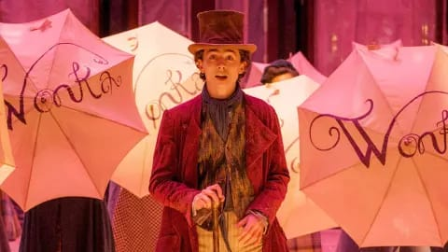

**(CNN) —**

Willy Wonka’s back. The chocolatier and torturer of naughty children is getting the prequel treatment in a new film starring Timothee Chalamet, coming to cinemas in December.

First footage of Chalamet as the mercurial Roald Dahl character was revealed Tuesday, showing a young Wonka setting out on a quest to shake up the chocolate industry and break up a confectionary cabal.

Chalamet steps into shoes previously filled by Gene Wilder in 1971 and Johnny Depp in 2005. Rather than retell Dahl’s 1964 book “Charlie and the Chocolate Factory,” writer-director Paul King has imagined a plucky, striving take on the character in what he calls a “companion piece” to the 1971 film.

Speaking in London ahead of the teaser trailer release, King promised an all-singing, all-dancing Chalamet and a film **that** “answers all the questions you never had” about Wonka.

The director shared that he’d accessed Dahl’s personal archives and read early drafts of the novel, gleaning ideas from there.

“As a writer, obviously I don’t remotely think of myself in the same breath as Roald Dahl,” he said, “but it was very nice to be so inspired by **that**.”

King, director of the beloved “Paddington” and “Paddington 2,” has cast familiar faces including Sally Hawkins, Tom Davis and Simon Farnaby, alongside Olivia Colman, Rowan Atkinson, Keegan-Michael Key and newcomer Calah Lane. And in a casting coup for the ages, the film sees King team up once more with Hugh Grant, this time playing a grumpy, flute-playing Oompa-Loompa.

The director said he was looking for a star to play one of Wonka’s “incredibly sarcastic and judgemental and cruel” workers and landed on Grant, “the funniest, most sarcastic s— **that** I’ve met.”

Much of the movie was filmed on studio soundstages, said King, although some scenes were shot on location in the UK, offering a glimpse of the hysteria **that** follows his star.

“I got an insight into Timothée Chalamet’s life, **which** is people leaning out of windows and screaming, ‘Marry me!’” he recalled, chuckling. “It was quite strange … I don’t know what they thought was going to happen.”

King’s gratitude towards Chalamet was palpable: “It was a huge commitment for him because it was a very long shoot and there was a lot (of) singing and dancing.”

“What’s so fabulous about him is you feel a lot of people his age would have been tempted to put on a superhero outfit and then sort of go and save the world,” he added. “And I managed to get him to put on a pair of heeled leather boots and do some tap dancing.”

“Wonka” is released in North American on December 15. CNN and Warner Bros. Pictures are units of Warner Bros. Discovery.

Source : <https://edition.cnn.com/2023/07/11/entertainment/wonka-trailer-timothee-chalamet-paul-king-qa/index.html>

Translate the sentence (with relative pronouns)

1. all-dancing Chalamet and a film that “answers all the questions you never had” about Wonka.

**Chalamet yang bisa menari dan film yang "menjawab semua pertanyaan yang tidak pernah Anda miliki" tentang Wonka**.

1. “but it was very nice to be so inspired by that.”

**"Tapi sangat menyenangkan bisa terinspirasi oleh hal itu."**

1. “the funniest, most sarcastic s— that I’ve met.”

**"orang yang paling lucu dan paling sarkastik yang pernah saya temui."**

1. offering a glimpse of the hysteria that follows his star.

**Menawarkan sekilas tentang histeria yang mengikuti bintangnya.**

1. “I got an insight into Timothée Chalamet’s life, which is people leaning out of windows and screaming, ‘Marry me!’”

**"Saya mendapatkan wawasan tentang kehidupan Timothée Chalamet, yaitu orang-orang yang mencondongkan tubuh mereka ke luar jendela dan berteriak, 'Menikahlah denganku!"**

Nama : Alifia Putri Aditya

NPM : 230302025

Kelas : TI 1B